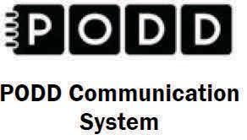

Dates: December 7-8, 2017

Thursday and Friday
Location:
Minnesota Department of Education 1500 Highway 36 West
Roseville, MN 55113

2-Day Introductory Workshop for: Teachers, Speech Pathologists, Autism Specialists, Parents, ParaEducators
(anyone working with students who have complex communication needs)
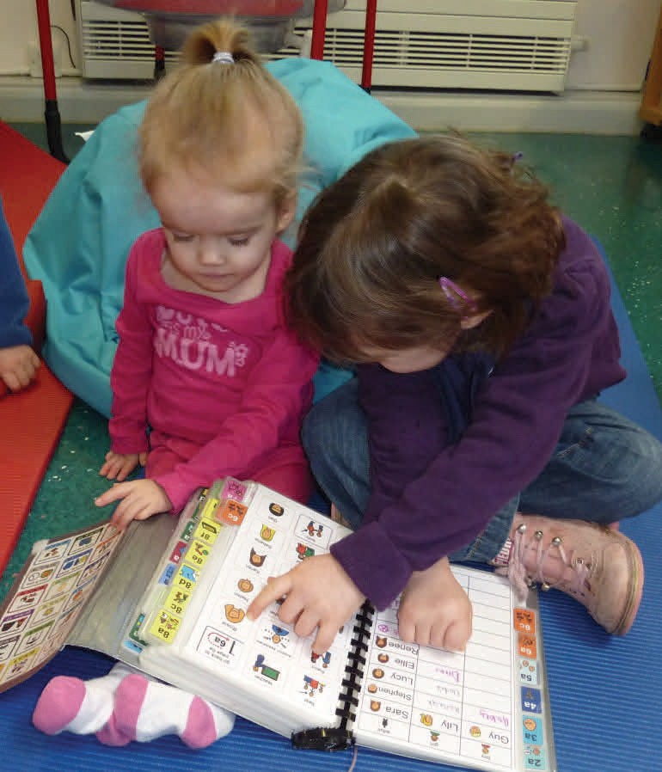

Introduction to the PODD

Communication System

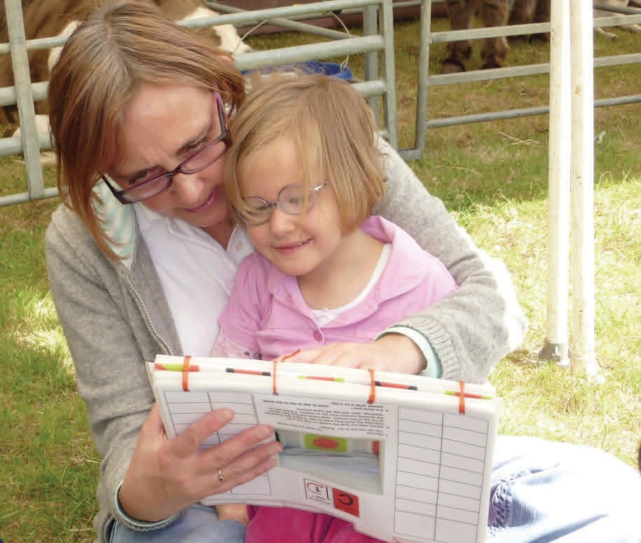

This training is limited to 40 participants
PREREGISTRATION IS REQUIRED
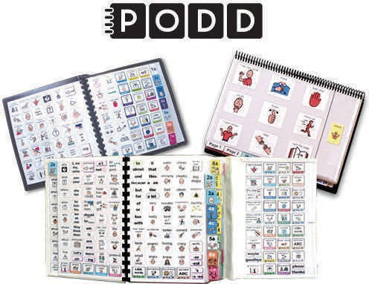
WHAT IS PODD TRAINING?

- Children who are nonspeaking or have only limited speech, in addition to other challenges, often struggle to interact and communicate. This may include children who have physical disabilities, multiple disabilities, sensory processing challenges, limited social interactions skills, and/or a range of cognitive limitations and learning difficulties.
- This two day course will demonstrate the use of a Pragmatic Organization Dynamic Display (PODD) approach developed by Gayle Porter (Melbourne, Australia). Generic templates for multi- page ‘light tech’ communication books have been carefully designed to support genuine communication for a variety of functions throughout the day. These templates may be customized for a range of access methods and other individual needs.
- Come learn strategies for creating multi- modal language learning environments that provide receptive models and expressive opportunities for language development. Learn strategies for teaching and using PODD with children and their communication partners. Videos and case examples will be shared.
- Participants will have an opportunity for hands-on practice with PODD Communication books.

2 DAY PROGRAM
Day One
- The challenge, aided language development.
- Development and general features of PODDs.
- Features of PODD communication books.
- Selecting and customizing PODD templates.

Day Two
- Access methodologies.
- Creating an aided language learning environment.
- Providing receptive input.
- Providing opportunities for expressive communication.
- Scaffolding interactions.
- Developing operational skills.
- Communication partner learning.
- Where to begin—where to from here?

Outcomes — 2 day

Participants will be able to:
- Describe the challenges faced by professionals creating communication systems in relation to vocabulary organization, layout, design, range of access strategies and customizing for individual requirements.
- Discuss the importance of receptive language input and creating a language learning environment.
- Discuss the features of a PODD communication system, including vocabulary organization, layout, design, range of access strategies and customizing for individual requirements.
- Use PODD generic template resources to produce customized communication books.
- Discuss the teaching and learning strategies for implementing PODD.

PODD Training Details
- Dates: December 7-8, 2017
- Length: 8:30-4:30 each day
(1-hour lunch & two 15-minute breaks each day.)
- Cost:
$190 (make check payable to Metro ECSU – mail to Metro ECSU, Gail Jankowski, 2 Pine Tree Drive, Suite 101, Arden Hills MN 55112)
- Location:
Minnesota Department of Education
1500 Highway 36 West
Roseville, MN 55113
Conference Center A, Room 14

- Presenter:

Kelly Fonner, MS,

Assistive/Educational Technology
Consultant & Certified PODD Presenter
- Click the following link to Register: http://metroecsu.myquickreg.com/register/event/

- Registration Deadline: 12/5/2017

